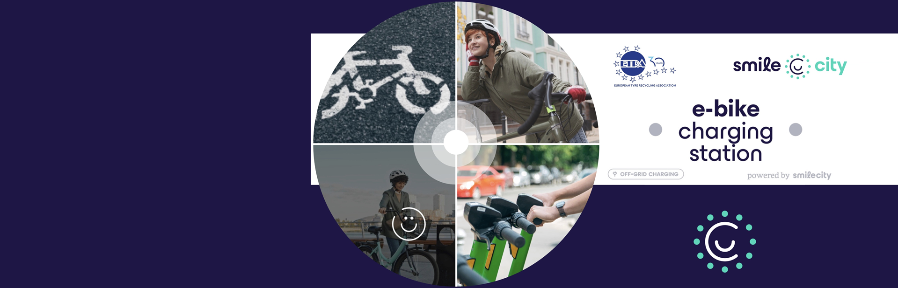

Faber School: Urban Living Lab “SMILE CITY”: Call for Co-Creation and Prototyping of Sustainable Urban E-Mobility Solutions
Comune di Lucca is pleased to highlight the launch of the Faber School-Urban Living Lab “SMILE CITY” initiative, an open innovation call designed to engage architects, designers, makers, students, researchers, and innovators in shaping the future of sustainable urban mobility. This opportunity is part of the European Horizon project SMILE CITY (Sustainable Materials for Innovative, Low Emissions Applications in the Circular City) and implemented in collaboration with Lazio Innova, its Spazio Attivo network and distributed FabLab infrastructure, and ETRA – European Tyre Recycling Association.

About the Initiative
The Faber School-Urban Living Lab SMILE City is a dynamic co-design and prototyping programme that invites multidisciplinary talents to respond to one of SMILE CITY’s core innovation challenges: the design of an off-grid e-bike charging station powered by renewable energy and built with circular economy principles. This station will serve as a scalable infrastructure prototype for sustainable urban mobility across European cities.
By joining this initiative, participants will collaborate within an international ecosystem of partners drawn from research institutions, industry, local authorities, universities and civil society, contributing to a real-world solution that embodies sustainability, functional design, and technical feasibility.

Who Can Participate
The call welcomes applications from a broad spectrum of profiles, including:
- University and ITS students
- Recent graduates, researchers and scientists
- Designers, architects and makers
- Digital artisans, technicians and local innovators
- Professionals and companies interested in sustainable design, renewable energy and circular economy solutions
This multidisciplinary cohort ensures a rich blend of perspectives and competences throughout the ideation and prototyping phases.

Challenge Focus and Expected Outcomes
Participants are invited to develop a functional architectural concept that integrates:
- A robust support structure for roof-mounted photovoltaic panels
- A secure and accessible housing for second-life batteries for energy storage
- Optional elements enhancing urban experience, including seating, lighting, and information interfaces
Design proposals should balance aesthetics, functionality, durability, safety, and replicability, while reflecting the principles of circular economy and urban sustainability championed by the SMILE CITY project.

Programme Structure
The initiative is structured in four key phases:
- Introductory Workshops: A series of preparatory sessions to:
  - Present the SMILE CITY partnership and its expertise network
  - Deep-dive into the call objectives and technical materials
  - Facilitate networking and exchange among participants and project partners
- The first workshop took place on 3 December 2025 at CNR – Rome, with follow-ups in early 2026 at Sapienza University, Politecnico di Torino (17/12/2025) and ISIA Faenza.
- Call for Applications: Submissions are open until 10 January 2026 (18:00 CET). Applications are evaluated by a panel including representatives from Lazio Innova, ETRA and sector experts.
- Co-Design and Prototyping Phase: A blended programme of in-person and digital sessions hosted through the FabLab network and across partner locations, fostering cross-fertilisation among international teams.
- Demo Day & Final Presentation: Each working group will present a suite of outputs from CAD drawings and scale models to presentations and illustrative media before an international expert jury.
Selected teams will gain:
- Involvement in SMILE CITY project activities,
- Recognition and visibility across project communications,
- Rights to reference their concept and prototype in professional portfolios,
- Travel cost reimbursement for project-related meetings.

Why It Matters
Urban Living Labs like this embody Europe’s push for participatory innovation, linking design, technology, sustainability and community needs within real urban contexts. The SMILE CITY project aims to pioneer circular, low-emission urban environments, with infrastructure solutions that are adaptable, scalable and citizen-centric.
This open call not only creates tangible outcomes in sustainable mobility infrastructure but also fosters international collaboration, knowledge exchange, and real-world impact for participants poised to become leaders in innovation, design and sustainability.

Apply and Engage
Interested innovators and teams are encouraged to apply by 10 January 2026. For full details and application procedures, Click Here

